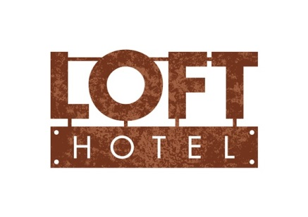

Information on the processing of personal data for the purpose of providing hotel services
In connection with the processing of your personal by LOFT HOTEL, p. r. o., we provide you, as the person whose personal data we process (hereinafter referred to as the data subject), with information pursuant to Articles 13 and 14. of Regulation (EU) 2016/679 of the European Parliament and of the Council of 27 April 2016 on the protection of individuals with regard to the processing of personal data. and on the free movement of such data (hereinafter referred to as
Personal data controller:
LOFT HOTEL, p. r. o., Štefánikova 4, 811 05 Bratislava
Purpose of processing:
Records of hotel services, hotel guests, room reservations, records of personal data in the hotel system in the bank of guests and records of guests - foreigners
Legal basis for the processing of personal data:
Act no. 40/1964 Coll. Civil Code
Act no. 455/1991 Coll. on trade license
Act no. 595/2003 Coll. on income tax
Act no. 582/2004 Coll. on local taxes and local fees for municipal waste and small construction waste, as amended
Act no. 222/2004 Coll. on value added tax
Act no. 404/2011 on the stay of aliens and on the amendment of certain laws
Act no. 431/2002 Coll. on accounting
Act no. 496/2008 Coll. full text Act no. 253/1998 Coll. on the registration of residence of citizens of the Slovak Republic and the register of inhabitants of the Slovak Republic, as amended

Recipient categories:
Third parties:
Court, law enforcement agencies
Tax Office
Foreign Police
City of Bratislava

Recipients:
Alto Slovakia s.r.o., Sladkovicova, 3305921 Svit, IČO: 31664881
Arterio, p. r.o., M.R.Štefánika 17, 934 01 Levice, ID: 50182099

Broker:
Spojná spol s r.o., Štefánikova 4, 811 05 Bratislava, ID: 45469938
Verifin s.r.o., Štefánikova 4, 811 05 Bratislava, ID: 50833863

List of personal data:
Name, surname, title, residence, ID card number, Name, surname, title, residence, ID card number of other accommodated guests, name, surname, title, date and place of birth of the alien, nationality, permanent residence in the home state, purpose of travel to the Slovak Republic, passport number, visa: type, number, validity, name and address of the accommodation facility in the Slovak Republic, accompanying children, length of stay in Slovakia, email, telephone number, credit card number and expiration

Retention period of personal data:
According to current legislation.

Rights of the person concerned:
The right to request access to your personal data
The right to correct personal data
The right to delete personal data
The right to restrict the processing of personal data
The right to object to the processing of personal data
The right to transfer your personal data
The right to lodge a complaint to the supervisory authority, i. Office for Personal Data Protection of the Slovak Republic
Those rights of the person concerned are further specified in Articles 15 to 21 of the Regulation. The person concerned shall exercise those rights in accordance with the Regulation and other relevant legislation. Against the company LOFT HOTEL, s. r. about. the person concerned may exercise his rights by written request or by electronic means. Where the data subject requests oral information, the information may be provided provided that the person concerned has proved his or her identity.

Contact details for the responsible person:
zo@eurotrading.sk

